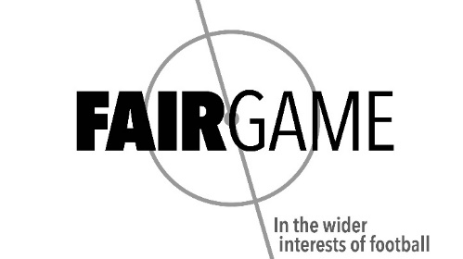

FINANCIAL BRIEFING

Background

In 2020, 52% of the clubs in our top four divisions – that is before the pandemic – were technically insolvent. That is clearly unsustainable. If you strip out the Premier League that figure rises to 61%.

In line with the English Football League, Fair Game believes the percentage allocated from the Premier League’s broadcast rights (£2,340m according to Deloitte in 2020) should return to pre-Sky levels of 25%, equating to a sum of £585m.

If this split was achieved, and then combined with Fair Game’s aspirations of a 10% Solidarity Transfer Levy (estimated to bring in £160m), this would equate to a maximum available to be distributed throughout the pyramid of £745m.

To protect the ecosystem of football and removed vested interests, this money should be distributed by an independent regulator

There are a number of organisations that are currently almost entirely dependent on the Premier League for their funding. To ensure proper independence these organisations should be funded by the Independent Regulator, with 10% allocated to these organisations. These organisations include:
- The PFA
- The LMA
- The FSA
- Kick It Out
- Level Playing Field

This would leave a total of £670.5m to be reallocated (15% should be split as baseline funding and the remaining 75% split according to a Sustainability Index).

The Financial Split

At present the financial flow is split as follows
- 80% to Championships clubs (most of which goes in parachute payments to clubs relegated from the Premier League)
- 12% to League One clubs
- 8% to League Two clubs

However, the attendance split of these clubs are:
- 60% Championship
- 25% League One
- 15% League Two

The voting
- 50% Championship
- 33% League One
- 17% League Two

However, there are also issues around the cliff-edges between divisions and also funding to the National League and the Women’s Game. Financial experts from Liverpool University, Birkbeck University, Sheffield Hallam University, Northumbria University and the University of Portsmouth (including Kieran Maguire, Rob Wilson, Dan Plumley, Christina Philippou, Richard Evans and Mark Middling) have analysed in the depth and have settled on a new proposed divisional split of:

- 46% Championship (24 teams)
- 24% League One (24 teams)
- 14% League Two (24 teams)
- 8% National League (24 teams)
- 4% National League North (22 teams)
- 4% National League South (22 teams)

Currently of the £585m, around 16% goes to the EFL. Of that 16% approximately:
- 11.5% goes on Parachute Payments
- 3.2% goes to Championship clubs not in receipt of parachute payments
- 0.7% goes to League One clubs
- 0.5% goes to League Two

The consequences of backing Fair Game’s financial proposals

Division (parachute clubs excluded) | 2021/22 payment | Redistribution on existing pot | Uplift | Distribution on full Fair Game proposal | Uplift
Championship | £4,800,000 | £10,091,000 | £5,290,000 | £12,851,250 | £8,051, 250
League One | £720,000 | £5,265,000 | £4,545,000 | £6,705,000 | £5,985,000
League Two | £480,000 | £2,852,000 | £2,372,000 | £3,631,875 | £3,151,875

Note: The figures above are calculated on the assumption that every club achieves top marks in the Sustainability Index, which includes a metric on wages as % of revenue and other financial sustainability measures. Full details of the Index can be viewed here.

